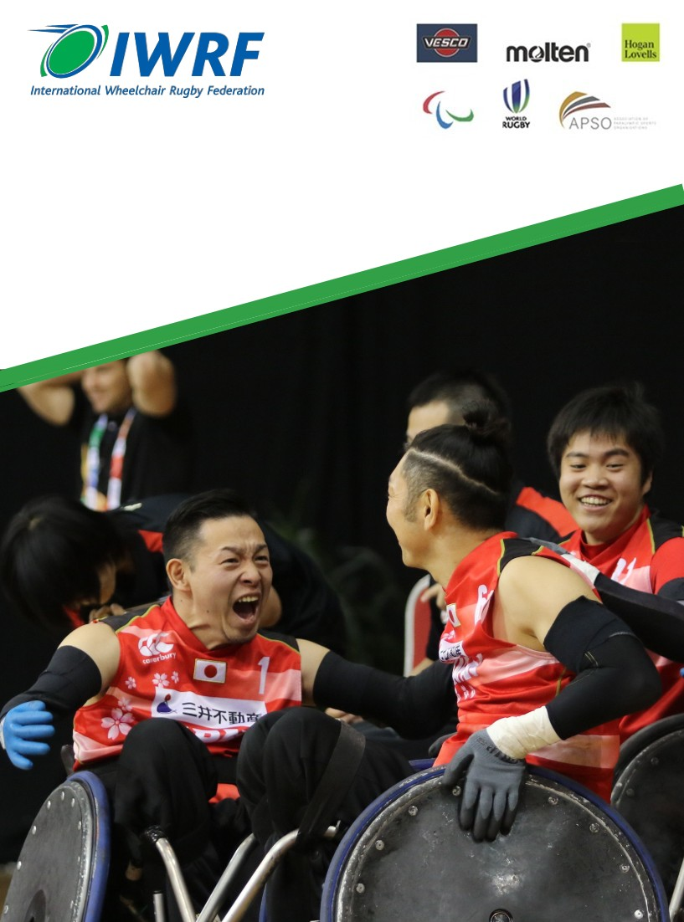

International Rules for the Sport of
Wheelchair Rugby

Updated :15th January 2021

International Rules for the Sport of Wheelchair Rugby

15 January 2021

International Wheelchair Rugby Federation

IWRF Office
4 Park Square,
Newton Chambers Road
Sheffield, England S35 2PH

Telephone:
+44 (0)114 257 3170

© Copyright 2021 IWRF

Table of Contents
SECTION 1. The Game 7
Article 1. Definition 7
SECTION 2. Field of play 7
Article 2. Field of play 7
Article 3. Court 7
Article 4. Boundary lines 8
Article 5. Centreline 8
Article 6. Centre circle 8
Article 7. Key area 8
Article 8. Try line 8
Article 9. Backcourt and frontcourt 8
Article 10. Scoring table 8
Article 11. Bench area 8
Article 12. Substitution area 9
Article 13. Penalty area 9
SECTION 3. Equipment 9
Article 14. Ball 9
Article 15. Game clock 9
Article 16. Forty Second Clock 9
Article 17. Signaling device 9
Article 18. Scoreboard 9
Article 19. Alternating possession directional arrow 10
Article 20. Record sheets 10
Article 21. Uniform 10
Article 22. Hand protection 10
SECTION 4. Wheelchair 10
Article 23. Compliance with specifications 10
Article 24. Width 10
Article 25. Length 11
Article 26. Height 11
Article 27. Wheels 11
Article 28. Anti-tip devices 11
Article 29. Bumper 11
Article 30. Wings 12
Article 31. Comfort and safety 13
Article 32. Modifications: 16
WHEELCHAIR Diagrams 17
SECTION 5. Teams 18
Article 33. Designation of teams 18
Article 34. Players 18
Article 35. Classification 18
Article 36. Rosters 18
Article 37. Captains 19
Article 38. Coaches 19
Article 39. Try and bench selection 19
SECTION 6. Officials 19
Article 40. Game Officials 19
Article 41. Officials’ jurisdiction 20
Article 42. Correctable errors 20
Article 43. Referees 20
Article 44. Responsibilities of Referee 1 21
Article 45. Game Commissioner 21
Article 46. Scorekeeper 22
Article 47. Timekeeper 22
Article 48. Forty Second Operator 22
Article 49. Penalty Timekeeper 23
SECTION 7. Timing regulations 23
Article 50. Playing time 23
Article 51. Game clock operations 23
Article 52. Forty Second clock operations 23
Article 53. Penalty clock operations 24
Article 54. Live ball 24
Article 55. Dead ball 24
Article 56. Time-outs 24
Article 57. Referees’ time-out 25
Article 58. Equipment time-out 26
Article 59. Fallen player 26
SECTION 8. Playing regulations 27
Article 60. Beginning the game 27
Article 61. Tip-off 27
Article 62. Alternating possession 27
Article 63. Location of a person 28
Article 64. Location of the ball 28
Article 65. Possession of the ball 28
Article 66. Playing the ball 28
Article 67. Dribbling the ball 29
Article 68. Scoring 29
Article 69. Throw–in 29
Article 70. Substitutions 30
Article 71. Held ball 30
SECTION 9. Violations 30
Article 72. Sanction 30
Article 73. Backcourt violation 31
Article 74. Ball out-of-bounds violation 31
Article 75. Twelve-second violation 31
Article 76. Kicking violation 31
Article 77. Out and in violation 31
Article 78. Physical advantage violation 32
Article 79. Ten-second dribble violation 32
Article 80. Ten seconds in the key violation 32
Article 81. Throw-in violations 32
Article 82. Time-out violation 32
Article 83. Tip-off violations 32
Article 84. Forty Second violation 33
SECTION 10. Principles of contact 33
Article 85. Safety 33
Article 86. Position on the court 33
Article 87. Vertical space 34
Article 88. Advantage 34
SECTION 11. Common Fouls 34
Article 89. Definition and sanctions 34
Article 90. Charging foul 35
Article 91. Contact before the whistle foul 35
Article 92. Four in the key foul 35
Article 93. Holding foul 35
Article 94. Leaving the court foul 35
Article 95. Pushing foul 36
Article 96. Illegal use of the hands foul 36
Article 97. Spinning foul 36
Article 98. One-meter foul 36
SECTION 12. Technical, Flagrant and Disqualifying fouls 36
Article 99. Definition and sanctions 36
Article 100. Player technical foul 37
Article 101. Bench personnel technical foul 37
Article 102. Equipment technical foul 38
Article 103. Excessive points technical foul 38
Article 104. Flagrant foul 38
Article 105. Disqualifying foul 39
SECTION 13. Penalties 39
Article 106. Serving penalties 39
Article 107. Release from the penalty box 40
Article 108. Multiple penalties 40
Article 109. Fouls during an interval 40
SECTION 14. Concluding the Game 40
Article 110. Deciding the game 40
Article 111. Ending the game 41
Article 112. Forfeit of game 41
Annex A - Field of play 42
Annex B – Score sheet 43
Annex C – Penalty sheet 44

To simplify the text, the male gender will be used to indicate both male and female persons. Any reference in the rules to a player should be interpreted to include the player’s wheelchair, unless otherwise specified.

Player safety is a fundamental principle in wheelchair rugby. The IWRF rules have been developed in accordance with these principles. Officials will endeavor to uphold these principles in their application of the rules.
- Wheelchair rugby is a physical sport; therefore, it is important that the game is played in accordance with the rules while being mindful of player welfare.
- Players have a responsibility to ensure they are physically and technically prepared to play the game within the rules and are committed to safe practices.
- It is the responsibility of the coaches to ensure players are prepared to comply with the rules, play fairly and practice safe conduct.
- It is the duty of the Referee to apply the rules fairly in all variants of the sport supported by the IWRF.

SECTION 1. The Game

Article 1. Definition
Wheelchair Rugby is a team sport for male and female athletes with a disability. The aim is to score tries by crossing the opposing team’s try line while in possession of the ball. The ball may be passed, thrown, batted, rolled, dribbled, or carried in any direction subject to the restrictions laid down in the rules. The team scoring the most tries by the end of the game is declared the winner.

SECTION 2. Field of play

Article 2. Field of play
The field of play includes the court where the game is played, and the surrounding areas used by the teams and team officials during the game. (See Annex A)

Article 3. Court
Wheelchair Rugby is played on an indoor court measuring fifteen (15) meters in width by twenty-eight (28) meters in length. The court shall be marked with boundary lines, centreline, centre circle, and two (2) key areas, as defined in Article 7. All lines on the court should be the same width and should be marked the same colour.

Article 4. Boundary lines
The boundary lines of the court consist of the end lines and the sidelines. The court dimensions are measured from the inside edges of these lines. The inside edges define the boundary between the in-bounds and out-of-bounds areas. All boundary lines are considered to be out-of-bounds.

Article 5. Centreline
The court shall be marked with a centreline across the width of the court from sideline to sideline at a distance fourteen (14) meters from each end line.

Article 6. Centre circle
The court shall be marked with a centre circle, positioned on the centreline with its centre a distance of 7.5 meters from each sideline. The centre circle shall have a radius of 1.8 meters, measured from the centre to the outer edge of the line marking the circle.

Article 7. Key area
The court shall include key areas at each end of the court, centred between the sidelines. Each key area shall be defined by two (2) lines marked perpendicular to the end line, joined by a line marked parallel to the end line. Each key area shall be eight (8) meters in width, measured from the outside edge of the lines marked perpendicular to the end line, and 1.75 meters in length, measured from the inside edge of the end line to the outside edge of the line marked parallel to the end line. The lines marking the key area are considered to be part of the key area.

Article 8. Try line
The try line is the portion of the end line that is within the key area. The ends of each try line shall be marked by posts. Each post must be a minimum of forty-five (45) centimeters high and must not exceed eighty (80) centimeters. Each post must have a square base. The posts shall be located out-of-bounds such that one side touches the inside edge of the end line and one side touches outside edge of the key area. The try lines and the posts are considered to be out-of-bounds.

Article 9. Backcourt and frontcourt
Each team has a backcourt and a frontcourt. A team’s backcourt is the area from the inside edge of the end line that includes the try line that team is defending up to and including the centreline. The frontcourt is the area from the centreline to the inside edge of the end line that includes the try line the opposing team is defending. The centreline is considered to be part of each team’s backcourt area.

Article 10. Scoring table
The field of play shall include a scoring table located at the centreline outside of the court and a minimum 1.5 meters from the sideline. (See Annex A)

Article 11. Bench area
The field of play shall include two (2) bench areas, outside the court on the same side as the scoring table. The ends of each bench area shall be defined by lines two (2) meters in length, beginning at and perpendicular to the sideline. One line shall extend from the end line and the other shall be marked five (5) meters from the centreline. The lines marking the bench areas may be marked in a different colour to that used for the lines marking the court.

Article 12. Substitution area
The field of play shall include a substitution area, located outside the court between the team bench and the scoring table. The beginning of the substitution area shall be defined by a line two (2) meters in length, beginning at and perpendicular to the sideline, three (3) meters from the centreline. The end of the substitution is the line marking the beginning of the team bench area. The lines marking the substitution area may be marked in a different colour to that used for the lines marking the court.

Article 13. Penalty area
The field of play shall include a penalty area on the side of the court opposite the scoring table. This area will include two (2) penalty boxes, one (1) on each side of the centreline. Each penalty box shall be marked by three (3) lines. The first line should be two (2) meters in length parallel to the sideline, marked one (1) meter from the sideline and beginning one (1) meter from the centreline. The other two (2) lines should be marked perpendicular to the first line and beginning at each end of it, running one (1) meter in length away from the sideline. The exit for the penalty box shall be shown by two (2) lines, thirty (30) centimeters in length, marked as an extension of the line one (1) meter from the centreline and at the midpoint of the penalty box. Each team will be assigned the penalty box that is directly opposite its bench area. A penalty table shall be positioned between the two (2) penalty boxes, directly opposite the scoring table and a minimum 1.5 meters from the sideline. (See Annex A)

SECTION 3. Equipment

Article 14. Ball
The game shall be played with an IWRF approved ball. The ball shall be inflated to at least 7.5 pounds pressure. Referee 1 shall be the sole judge as to the suitability of the ball provided.

Article 15. Game clock
The scoring table shall be provided with a timing device or devices to time the periods of play, penalties, and time-outs. This shall be the official game clock.

Article 16. Forty Second Clock
The scoring table shall be provided with a timing device or devices to time the forty (40) second scoring period. The forty (40) second device will have a distinct sound that is different from the game clock.
The forty (40) second device must be able to be reset to fifteen (15) seconds.

Article 17. Signaling device
The scoring table shall be provided with a device or devices to provide an audible signal of the expiration of playing time, time-outs, requests for substitutions, and other situations requiring the attention of the Referees. This may be integrated with the game clock or scoreboard.

Article 18. Scoreboard
The field of play should be equipped with a device to present the running score of the game to the players and spectators. This device may be operated manually, mechanically, or electronically. It may include the game clock as part of the display.

Article 19. Alternating possession directional arrow
The scoring table shall be provided with a device to display the direction of play for the next possession under the alternating possession procedure detailed in Article 62. This device may be operated manually, mechanically, or electronically, and may be incorporated into the scoreboard or game clock.

Article 20. Record sheets
The scoring table and penalty table shall be provided with record sheets to record the score of the game and the penalties served during the game. The standard score sheet is provided at Annex B. The standard penalty sheet is provided at Annex C.

Article 21. Uniform
On each team, all uniform tops must be of the same colour and shade. Anything worn under the uniform top that is visible must be of the same colour and shade as the dominant colour of the uniform top.
On each team, all uniform bottoms must be of the same colour and shade. The uniform bottom may be a different colour from the uniform top. Anything worn under the uniform bottom that is visible must be of the same colour and shade as the dominant colour of the uniform bottom. On each team, individual players may wear either long or short uniform bottoms.
All uniform tops shall bear a number between 1-15, 20-25, 30-35, 40-45 and 50-55 inclusive, on the front and back. Each player on a team must have a different number. The number on the front must be on the players right side and the height must be no less than six (6) centimeters and no more than ten (10) centimeters. The number on the back must be in the centre and must be no less than fifteen (15) centimeters and no more than twenty (20) centimeters high. Both numbers must be visible at all times. Numbers may also be marked on the backrest of the wheelchair. No other numbers may appear on the uniform.
For games at IWRF-sanctioned tournaments, the Technical Delegate shall decide the uniform colour to be worn by each team for all games.
Additional details regarding uniform specifications can be located in the IWRF Logo, Branding and Partnership Guidelines. https://www.iwrf.com/resources/iwrf_docs/IWRF_Classifier_Handbook_2021_Final_Draft.pdf.

Article 22. Hand protection
Players may wear any form of hand protection; however, it cannot include any material that may be hazardous to other players, such as hard or rough material.

SECTION 4. Wheelchair

Article 23. Compliance with specifications
The wheelchair is considered to be part of the player. Each player is responsible for ensuring that their wheelchair meets all specifications for the duration of the game. If a wheelchair does not meet these specifications it shall be barred from the game until it is brought into compliance.

Article 24. Width
There is no maximum width of wheelchair. No point on the wheelchair may extend in width beyond the widest point of the push rims.

Article 25. Length
The length of the wheelchair as measured from the front-most part of the back wheel to the front-most part of the wheelchair cannot exceed forty-six (46) centimeters. (See Wheelchair diagram B)

Article 26. Height
The height of the wheelchair, as measured from the floor to the midpoint of the seat side rail tubing halfway between the front and back of the side rail, cannot exceed fifty-three (53) centimeters. (See Wheelchair diagram B)

Article 27. Wheels
The wheelchair shall have four (4) wheels. The two (2) large wheels at the back that are used to propel the wheelchair are referred to as the main wheels; the two (2) small wheels at the front are referred to as the casters. (See Wheelchair diagram A)
- The main wheels shall have maximum diameter of seventy (70) centimeters. Each main wheel must be fitted with a spoke guard that protects the area contacted by another wheelchair, and a push rim. There shall be no bars or plates extending around the main wheels. The rearmost part of the main wheel shall be considered the back of the wheelchair and nothing can extend past this point. (See Article 28)
- The casters must be on separate axles positioned a minimum of
Twenty (20) centimeters apart, measured centre to centre. The housing that holds the caster must be positioned no more than 2.5 centimeters away from the main frame of the wheelchair, measured from the inside edge of the housing to the outside edge of the mainframe.

Article 28. Anti-tip devices
The wheelchair shall be fitted with an anti-tip device attached at the rear of the wheelchair which must contain two (2) wheels a minimum of forty (40) centimeters apart, measured centre to centre. If the wheels of the anti-tip device are fixed, they cannot project further to the rear than the rearmost point of the main wheels. If the wheels of the anti-tip device swivel, the housing that holds them cannot project further to the rear than the rearmost point of the main wheels. The bottom of the wheels of the anti-tip device must be no more than two (2) centimeters above the floor. (See Wheelchair diagram B).

Spring-loaded anti-tips are prohibited.
To simplify the text, bumper will be used to indicate a bumper or pick bar. The terms are interchangeable.

Article 29. Bumper
The wheelchair may be equipped with a bumper projecting from the front of the wheelchair. The bumper, or the front-most part of the wheelchair if no bumper is present, must conform to the following requirements:
- The front-most part of the bumper, measured to the midpoint of the rod or tubing with the casters in a forward-rolling position, must be eleven
(11) centimeters from the floor. An allowance of five (5) millimeters either above or below eleven (11) centimeters is permitted. (See Wheelchair diagram B)
- The front-most part of the bumper must be a minimum of twenty (20) centimeters wide measured side to side and must span straight across. An allowance of ten (10) millimeters is permitted in the horizontal plane due to general play damage.
- At its front-most point, the bumper must not extend more than twenty
(20) centimeters beyond the forward edge of the caster housings. (See Wheelchair diagram B)
- At its widest point, the bumper must not extend more than two (2) centimeters beyond the outside edges of the caster housings on each side of the wheelchair. (See Wheelchair diagram A)
- The lowest point of the bumper must be a minimum of three (3) centimeters above the floor. (See Wheelchair diagram B)
- The highest point of the bumper must be no more than twenty (20) centimeters above the floor. (See Wheelchair diagram B)
- The rod or tubing used for the bumper must be a minimum of 0.635 centimeters in diameter. (See Wheelchair diagram C)
- The rod or tubing used for the bumper must be rounded and can have no edges or protrusions that could give a player an unfair mechanical advantage.
- All rods or tubing used for the bumper should be bent on a bender so that all corners are round. The bends shall not cause the tube to wrinkle, flatten, or flare.
- The inside curvature of all bends must be a minimum of two (2) centimeters in diameter.
- The minimum outside measurement of any portion of the bumper, measured from outer edge to outer edge, is 3.27 centimeters. (See Wheelchair diagram C)
- There must be a bar from the bumper towards the main frame of the wheelchair extending from the widest point of the bumper. This bar must be straight and must be made at an angle of forty-five (45°) or greater from the bumper to the main frame, measured in the horizontal plane as viewed from above. Note: This bar does not have to attach to the main frame.

Article 30. Wings
The wheelchair may be equipped with wings on either side in the area between the front of the wheelchair and the main wheels. Each wing must conform to the following requirements:
- The outer-most point of contact of the wing must be exactly eleven (11) centimeters from the floor in front of the caster housing.
  - The wing must not extend beyond the centre of the tire on the main wheel.
  - First point of contact on the wing behind the caster housing must be at eleven (11) centimeters or below.
- The lowest point of the wing must be a minimum of three (3) centimeters from the floor. (See Wheelchair diagram B)
- The highest point of the wing must be no more than twenty (20) centimeters from the floor. (See Wheelchair diagram B)
- The rod or tubing used for the wing must be a minimum of 0.635 centimeters in diameter.
- The wing may stop at the rear wheel or it may continue past the rear wheel with a connection to the main frame. A wing that stops at the main wheel must conform to the following additional requirements:
  - It must be rounded at the end without any sharp edges.
  - It must end within one (1) centimeter of the main wheel. (See Wheelchair diagram B)
- The space above the wing, extending from the top edge of the wing to ten (10) centimeters above the top edge of the wing and from the front of the wing to one (1) centimeter behind the tire of the main wheel, must be obstacle free.

Article 31. Comfort and safety
The wheelchair must conform to the following additional specifications:
- All protrusions from the wheelchair, such as push-bars, crossbars, ball holders or hooks, must be padded. Note: Handles for pushing the chair are not permitted.
- No steering devices, brakes, gears, or other mechanical devices are permitted to help operate the wheelchair. If the wheelchair is equipped with such devices, they must be modified so they are not operational and must be repositioned, so they do not represent a safety hazard.
- The wheelchair may be fitted with a device under the front end to prevent it from tipping forward. This device must conform to the following specifications:
  - It cannot be the front-most point of the wheelchair.
  - There is no minimum height above the floor, but it may not be in constant contact with the floor.
  - It cannot damage the floor.
  - Any contact between this device and the floor will be governed by the Physical Advantage rule (Article 78).
- Tires must not leave noticeable marks on the playing surface.
- No counterweights may be added to the wheelchair.
- One (1) cushion, with a maximum thickness of ten (10) centimeters, is permitted on the seat of the wheelchair.
- A player may use padding between his knees. This padding must not protrude above the top of the knees.
- A player may be strapped to the wheelchair.
- If there is a possibility of a player’s feet slipping off the footrest of the wheelchair, a strap or elastic must be used behind the legs or around the feet to prevent this from occurring.
- A player may use an additional device to support the ball. The support device, or ball holder, must make contact with no more than the bottom twenty-five (25) percent of the ball. The ball holder must ensure that seventy-five (75) percent of the ball is visible to be played.
Note: Percentage refers to the diameter of the ball.

- When a ball holder is fitted to a chair, it must be rigid and made from materials measuring no less than nineteen (19) millimeters in diameter.
- The ball holder may be permanently mounted to the chair or fixed to the frame with brackets that allow the device to be removable or adjusted.
- The primary function of the ball holder must be to support the ball. When the ball is placed in the device, and the athlete is in a neutral position, the ball must rest against the device. The ball holder must partially support the ball to remain on the lap.
- No part of the ball can rest within the frame.
- Seventy-five (75) percent of the ball must be visible above the height of the ball holder.
- The ball holder must not create a mechanical advantage (Example: it must be free of adhesive, cannot be spring loaded or allow the ball to be pressure fit within the device).
- The device must be well padded.
- If the ball holder is a closed shape, it must measure fourteen (14) centimeters or less between the widest two (2) points (inside measurement - including padding).

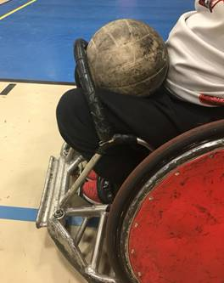 | Illegal:  1) The device is not supporting the ball  2) The device covers more than 50% of the ball | 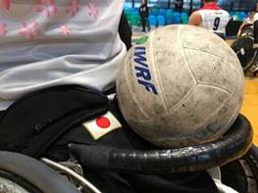 | Legal:  1) The ball is supported by the device  2) The ball holder is well padded  3) It is rigid as well as removable (spares were checked and are also legal)
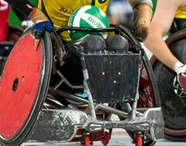 | Illegal:  1) The device is not supporting the ball  2) The device covers more than 50% of the ball | 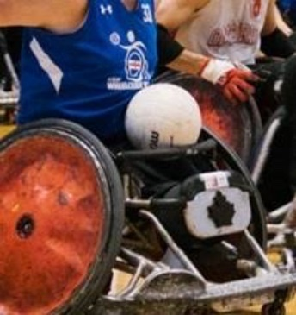 | Legal:  1) The device is supporting the ball  2) 75% of the ball is available to be played
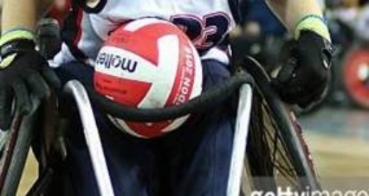 | Illegal:  1) The ball is inside the frame | 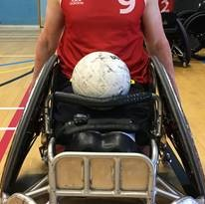 | Legal:  1) The device is supporting the ball  2) The ball is outside the frame
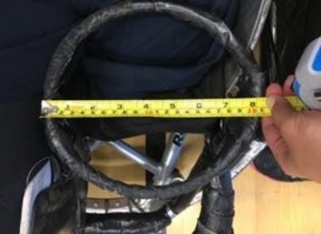  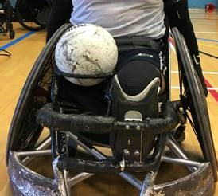 | Illegal:  1) Inside measure is greater than 14cm  2) The ball can be pressure fit to the device. | 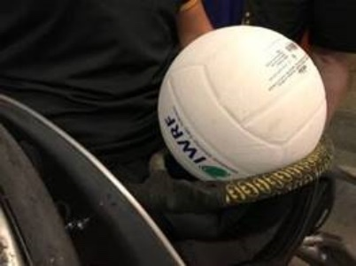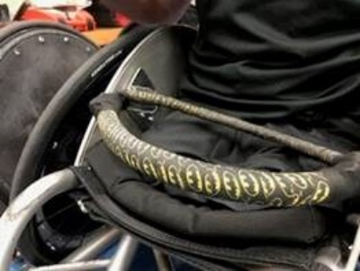 | Legal:  1) The measurement between the two (2) closest points is less than 14cm  2) 75% of the ball is available to be played  3) The device is supporting the ball

Article 32. Modifications:
Any part of the wheelchair or player equipment may be modified to improve comfort or safety or for medical reasons. These modifications must be safe, must conform to all the wheelchair specifications in these Rules, and may not create any mechanical advantage. Modifications made must be identified on the team’s short list/team roster and approved by the Technical Delegate and Head Official prior to the start of competition.
Innovative changes that give a mechanical advantage or that do not conform to the presently accepted norms for a wheelchair, as detailed in these Rules, may not be made without prior approval from the IWRF. Such changes must be presented to and approved by the Technical Commission of the IWRF, in writing.
Approval must be received no less than two (2) months prior to the commencement of World Championship, Zone Championship, or Paralympic Games, and one (1) month prior to any other sanctioned event. As the IWRF requires one (1) month to properly process a request and render a decision, requests should be made three (3) months prior to World Championship, Zone Championship, or Paralympic Games, and two (2) months prior to other sanctioned events.
The commencement of such events is the date of the opening ceremonies, or if there are no opening ceremonies, the date of the first day of competition.

WHEELCHAIR Diagrams

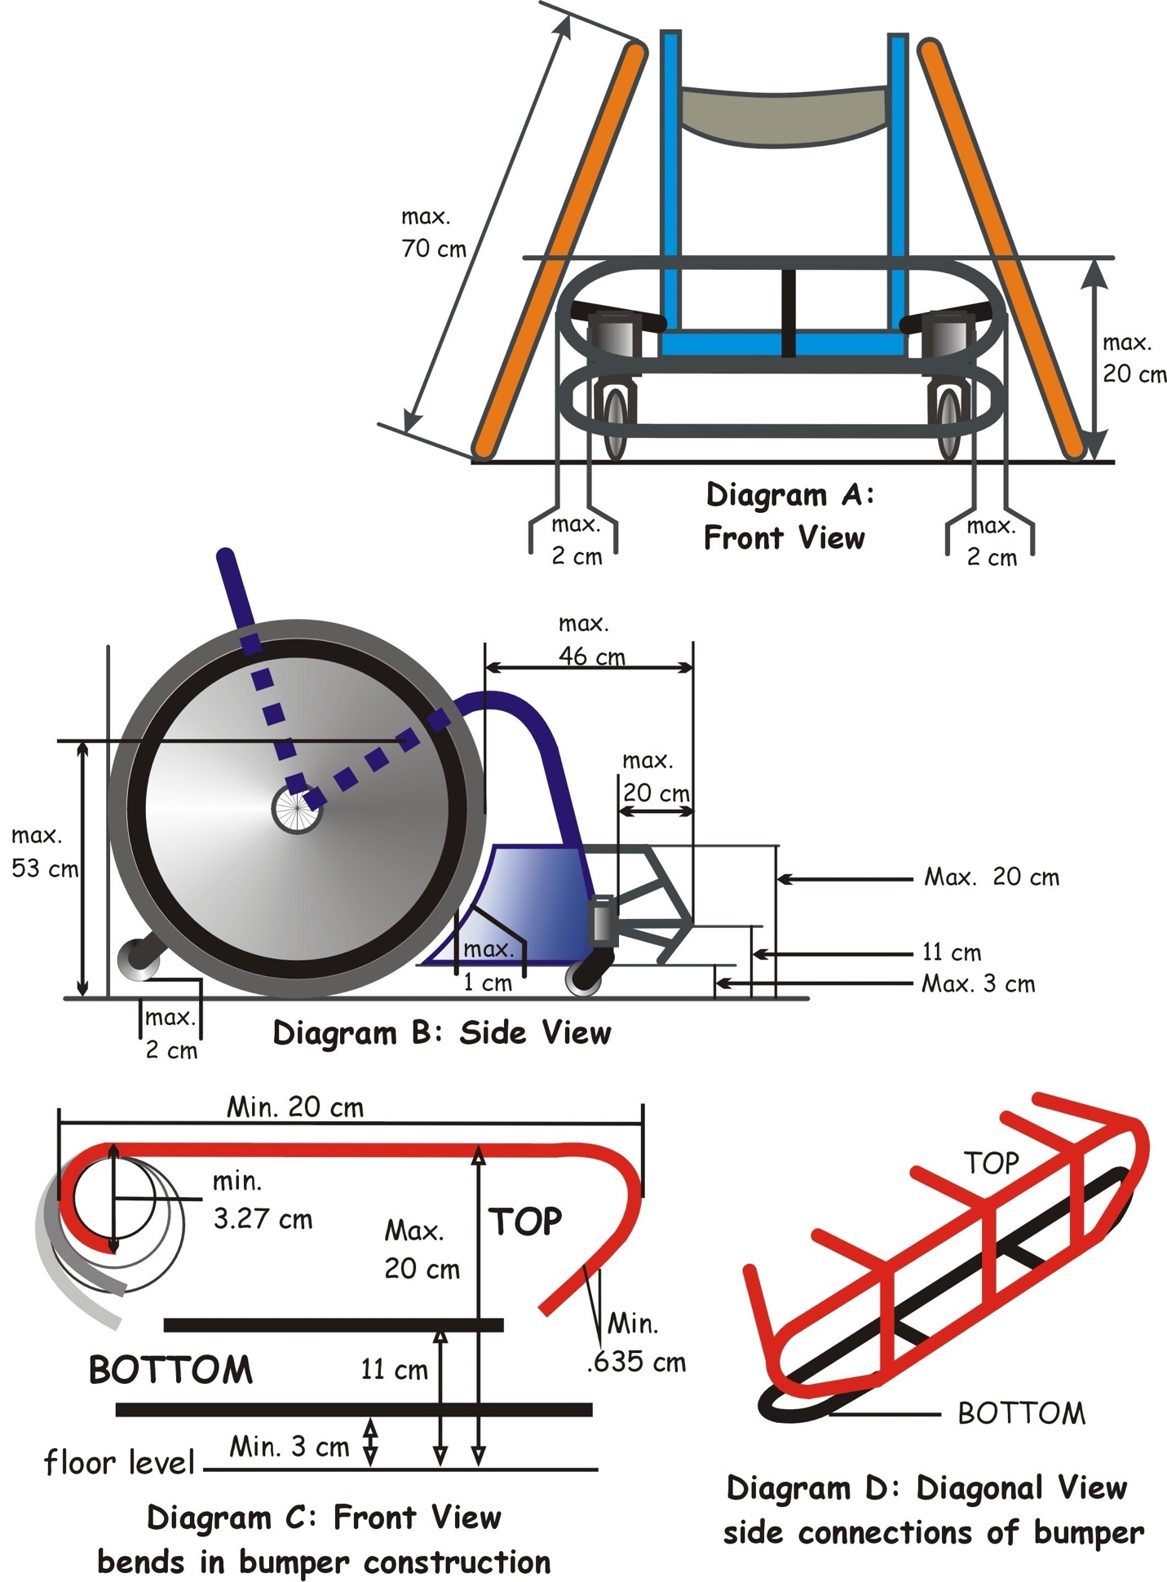

SECTION 5. Teams

Article 33. Designation of teams
The Home team shall be listed as Team A on the score sheet. When the game is played on a neutral court, the team appearing first on the official schedule shall be listed as Team A. At IWRF-sanctioned events, all playing venues will be considered as neutral.

Article 34. Players
Each team shall have a maximum of twelve members. No more than four (4) players from each team may be on the court at one time. Players serving penalties are considered to be on the court. Team members who are not on the court during play are termed substitutes.

Article 35. Classification
All players must be classified according to the IWRF classification system as detailed in the IWRF Classifier Handbook https://www.iwrf.com/resources/iwrf_docs/IWRF_Classifier_Handbook_2021_Final_Draft.pdf.
The sum of the classification points of a team’s players on the court must be eight (8) or less. For each female player on the court a team will be allowed an extra 0.5 points over and above the eight (8) points for the team.
If conditions such as injuries or disqualification, result in a team being unable to field four (4) players while respecting the maximum classification point value, the team shall be permitted to field three (3) players. In this case, the sum of the classification points of the players on the court must be less than eight (8).

Article 36. Rosters
No less than ten (10) minutes before the game is scheduled to begin, each coach shall confirm, with a signature, the following information inscribed on the score sheet:
- The names, classifications, and uniform numbers of all team members.
- Identify the four (4) players who will begin the game.
- The name of the team coach and assistant coach
The coach of Team A shall be the first to provide this information and then the coach of Team B. The coach of Team A will be allowed a second opportunity to review the scoresheet.
Starting players may not be substituted after the ten (10) minutes mark except in the case of a medical issue or equipment failure.
Each team must begin the game with four (4) players on the court. Only players who are listed on this roster shall be permitted to play. Substitutes who arrive late to the game may play if their names appear on the roster.

Article 37. Captains
Each team must designate at least one (1) captain. The captain is the only player from the team who is authorized to communicate with the officials on behalf of the coach or other players. The captain is responsible to work with the officials and his teammates to maintain proper court decorum.
The captain shall be distinguished from other players by inscribing the letter “C” next to their name on the score sheet.
When the captain leaves the playing court, an alternate captain shall be designated. The alternate captain can be distinguished by inscribing the letters “AC” next to their name on the score sheet.

Article 38. Coaches
Each team must designate a coach, whose name must be inscribed on the score sheet.
A team may designate an assistant coach, whose name must be inscribed on the score sheet. The assistant coach shall assume the responsibilities of the coach if for any reason the coach is unable to continue.
The team captain may act as coach. If the captain must leave the field of play due to a disqualifying foul, or if he is unable to continue to act as coach for any other reason, the alternate captain may replace him as coach.

Article 39. Try and bench selection
The team listed first on the schedule shall be assigned team bench A, the team listed second will be assigned team bench B. When facing the score table Team A shall occupy the area to the left of the score bench and Team B shall occupy the area to the right.
For the first half of the game, each team shall defend the try line that is closest to their bench area and shall score over the try line that is farthest from their bench area. For the second half, teams shall keep the same bench area but shall exchange the try lines they defend and score on.
In the event of overtime, teams shall keep the same try lines for all overtime periods as they had for the second half.

SECTION 6. Officials

Article 40. Game Officials
Each game shall be officiated by two (2) Referees, known as Referee 1 and Referee 2. The Referees shall be assisted by a Game Commissioner and the Table Officials.
The Table Officials will consist of a Scorekeeper, a Timekeeper, a Forty Second Operator and a Penalty Timekeeper.
During a tournament, all Referees and Game Commissioners shall be under the supervision of the Head Official. The Head Official is responsible for the assignment and supervision of Referees and Game Commissioners.
All Table Officials shall be under the supervision of the Head Table Official. The Head Table Official is responsible for the assignment and supervision of the Table Officials.

Article 41. Officials’ jurisdiction
The officials’ duties and authority begin when they arrive at the field of play and end with the expiration of all periods of regulation and overtime play as approved by Referee 1 by his signature on the score sheet. Any subsequent incidents should be noted on the score sheet and will be dealt with by the tournament organizers or other relevant authorities.
The Referees have authority to make decisions regarding infractions of the rules committed on the court and within the field of play. The Referees are authorized to deal with situations beyond the field of play when they have an effect on the field of play.
The officials are not authorized to approve any changes to these Rules.

Article 42. Correctable errors
An error in game administration may be corrected under the following circumstances:
- The error must be one of administration, such as applying an incorrect sanction or failing to start or stop the game clock or forty (40) second clock appropriately. Errors in judgment or interpretation by the Referees are not subject to correction.
- A request for correction must be made by a coach or team captain before the ball becomes live after the next stoppage in play following the error.
- The request must be made to the Scorekeeper, who should immediately note it and inform the Referees at the next stoppage in play.
If Referee 1 decides that a correctable error has occurred, everything that took place after the error is nullified and play is resumed from the point at which the error occurred. The clock and score shall be reset to the point where the error occurred.

Article 43. Referees
The Referees are to conduct the game in accordance with these Rules.
The Referees shall use the mechanics, procedures, and signals as detailed in the IWRF Referee Manual.

The Referees have the power to rule on any game situation that is not specifically covered in these Rules.
If verbal communication is necessary to explain a decision, the English language shall be used for all international games. This does not mean that a player or coach has the right to request an explanation for a call, nor that a Referee must speak English to carry out his duties. This applies only to situations involving confusion and lengthy delays in a game that are the result of events that are unusual or outside the scope of the Rules.
The Referees are empowered to remove a player from the court for the following reasons:

- If an official identifies that a player has suffered a significant blow to the head or the player is displaying the symptoms of concussion as per the IWRF Medical Guidelines - Concussion (See IWRF Concussion Guidelines).
- If a player has an open or bleeding wound, or other issues outlined in the IWRF Medical Guidelines, a sixty (60) second Referee time out will be provided. If the issue cannot be resolved in the time allotted the player(s) must be substituted. The player(s) may return to the game, through the typical substitution process, once the wound has stopped bleeding and has been cleaned and covered. Should a uniform become contaminated it must be cleaned, covered or replaced. If uniform replacement is required the score sheet will be amended, at no penalty, to reflect the change in number. (See IWRF Bodily Fluid Guidelines).

Any player that is removed under these rulings will not be permitted to return to the field of play until they have met the return to play criteria outlined in the IWRF Medical Guidelines.

Article 44. Responsibilities of Referee 1
Referee 1 has overall responsibility for the conduct of the game. He has the following additional duties:
- Inspect and approve all equipment used by players and officials.
- Disallow the wearing of any objects or use of any equipment judged to be dangerous.
- Acknowledge all other officials prior to the start of the game.
- Administer the tip-off at the start of the game, overtime periods and the inbound at the start of each quarter.
- Render the final decision on all conflicts or discrepancies regarding the operation of the game clock or scoreboard, or other areas under the jurisdiction of the table officials.
- Render a final decision on a correctable error.
- Declare the game a forfeit when conditions warrant. (Article 112)
- Verify that the score sheet is correct at the end of each period of play and at any other time it is necessary.

Article 45. Game Commissioner
The Game Commissioner has the following duties:
- Supervise the work of the table officials at the scoring table.
- Assist the Referees with the conduct of the game.
- Assist the Referees with any correctable error situations.
- Ensure the accuracy of the score sheet.
- Ensure the proper operation of the game clock.
- Ensure the proper operation of the forty (40) second clock.
- Ensure the proper operation of the scoreboard.
- Ensure the proper operation of the alternate possession direction arrow.
- Ensure the recording of time-outs.
- Assist the Referees with any chair protests and decision review (as referenced in the IWRF Decision Review Process).

Article 46. Scorekeeper
The Scorekeeper has the following duties:
- Verify that all required information is properly inscribed on the score sheet prior to the start of the game.
- Record all tries on the score sheet in chronological order.
- Record all time-outs on the score sheet, including the period, the team, and the player or coach who requested it.
- Monitor the total classification point value of all players on the court for each team and ensure that no team exceeds the maximum value. (Article 35)
- Operate the scoreboard when it is not integrated with the game clock.
- Operate the alternate possession arrow when it is not integrated with the game clock.
- Inform the Referee of any irregularities. This should be done at the first stoppage in play following the irregularity.

Article 47. Timekeeper
The Timekeeper has the following duties:
- Operate the game clock.
- Notify Referee 1 at the three (3) minute mark prior to the start of the game.
- Time all periods of play and intervals in regulation and overtime play.
- Indicate the end of each period of regular and overtime play.
- Time each time-out (Article 56) and equipment time-out (Article 58), providing an audible signal after fifty seconds have elapsed
- Notify the Referees of all requests for substitutions.
- Operate the scoreboard when it is integrated with the game clock.
- Operate the alternate possession direction arrow when it is integrated with the game clock.
- Inform the Referee of any irregularities. This should be done at the first stoppage in play following the irregularity.

Article 48. Forty Second Operator
The Forty Second Operator has the following duties:
- Operate the forty (40) second scoring clock.
- Start or restart the forty (40) second clock as per Article 52

Article 49. Penalty Timekeeper
The Penalty timekeeper has the following duties:
- Supervise the penalty box area.
- For each penalty awarded, record the following information on the Penalty Record Sheet:
- the time and period the foul was committed,
- the team that committed the foul (A or B), and
- the number of the player.
- Record warnings for contact before the whistle (Article 91).
- Time each penalty using the game clock.
- Indicate when penalized players may return to the court.
- Inform the Referee of any irregularities. This should be done at the first stoppage in play following the irregularity.

SECTION 7. Timing regulations

Article 50. Playing time
Wheelchair rugby is played in four (4) periods of eight (8) minutes. There is a two (2) minute or three (3) minute interval at the end of the first period and the third period. There is a five (5) minute or ten (10) minute interval at the end of the second period.
In the event of overtime, each period of overtime shall be three (3) minutes. There shall be a three (3) minute interval between the end of regulation play and the first overtime period. If additional overtime periods are required, there shall be a two (2) minute interval following each overtime period.

Article 51. Game clock operations
The game clock shall be started at the following times:
- When the ball is touched by a player after reaching its highest point during a tip-off.
- When the ball has been touched by a player on the court during a throw- in.
The game clock shall be stopped:
- At the end of each period of regulation and overtime play.
- When a try is scored.
- When a Referee blows his whistle to signal a violation, foul, time-out, or any other stoppage in play.

Article 52. Forty Second clock operations
The forty (40) second clock shall be started when touched by a player on court following a throw in from out of bounds and is restarted whenever a team gains possession of a live ball on the playing court. The mere touching of the ball by an opponent does not start a new forty (40) second period if the other team remains in possession of the ball.
The forty (40) second clock shall be stopped and reset to forty (40) seconds when:
- An official blows his whistle for a defensive foul or violation.
- An official blows his whistle for an offensive foul or violation that results in a change of possession.
- The game is stopped because of an action connected with the team not in possession of the ball.
The forty (40) second clock shall be stopped, but not reset to forty (40) seconds, when the same team that previously had possession of the ball is awarded a throw-in as a result of:
- A ball having gone out-of-bounds.
- A player of the same team requesting a Referee’s timeout (injury, equipment).
- A held ball situation where the team retains possession.
- An offensive foul where the team retains possession.
The forty (40) second clock shall be stopped and reset to fifteen (15) seconds when a team in possession of a live ball requests, and is awarded a timeout, and time remaining on the forty (40) second clock is less than fifteen (15) seconds.
Stopped and switched off when a team gains possession of a live ball on the playing court, and there are fewer than forty (40) seconds remaining on the game clock or fifteen (15) seconds remaining on the game clock after a timeout has been awarded in any period.

Article 53. Penalty clock operations
The game clock shall be used as the penalty clock to measure the timing of penalties.

Article 54. Live ball
The ball becomes live when the Referee blows his whistle:
- before entering the centre circle to administer a tip-off, or
- upon placing the ball at the disposal of a player for a throw-in.

Article 55. Dead ball
The ball becomes dead when the Referee blows his whistle to signal a try, a violation, a foul, a time-out, or any other stoppage in play.

Article 56. Time-outs
Each team has six (6) time-outs that may be taken any time during regulation play. There will be four (4) time-outs of thirty (30) seconds and two (2) of sixty (60) seconds. In the event of overtime, any time-outs remaining at the end of regulation play will be carried over into overtime play. In addition, each team will receive one (1) additional (30) second time-out per overtime period.
A request for a thirty (30) second time-out may be made by a coach or by a player. Only the coach or assistant coach may request a sixty (60) second time-out.
A time-out requested by a coach will only be granted when the ball is dead. The coach may make his request to the timekeeper at any time; the timekeeper will relay the request to a Referee at the next stoppage in play following the request.
A time-out requested by a player when the ball is live will be granted only if the player making the request, or a teammate of that player, has possession of the ball. The ball must not be in contact with the court (Article 3) or with a player from the opposing team. If the ball becomes live, and is intentionally placed on the floor by the Referee to begin the inbound process, the team in possession of the ball may request a time out.
When the Referee accepts a request for a time-out, he shall blow his whistle, signal that a time-out has been called, and indicate the team that has requested the time- out. This information shall be inscribed on the score sheet.
During a time-out, players may remain on the court or return to their bench. Coaches and team staff may not enter the court during a time-out; if players require assistance or wish to converse with a coach or team staff, they must return to their bench.
The team that requested the time-out may choose to terminate it and return to play at any time. The other team must resume play immediately.
If the full time-out is taken, a warning shall be sounded after twenty (20) seconds for a thirty (30) second time-out and fifty (50) seconds for a sixty (60) second time-out to indicate that teams should return to the court and prepare to resume play. When the time-out has expired, play shall resume with a throw-in.
Following the warning to resume play, players shall be given time to position themselves. If a Referee judges that a player or players are delaying, play shall resume as follows:
- If the team taking the throw-in is delaying, the Referee will begin the throw-in procedure at the appropriate point, placing the ball on the floor. If the in-bounding player takes his position before a violation of the throw- in occurs, the Referee shall place the ball at his disposal and continue the ten (10) second count.
- If the team not taking the throw-in is late, the Referee shall give the ball to the other team for the throw-in and play shall resume.

Article 57. Referees’ time-out
A Referee may stop play at any time to attend to and resolve any situation. The duration of this stoppage in play will vary with each situation. The following rules apply to specific types of situation:
- If a situation occurs which places any person in danger, the Referee shall stop play immediately. The stoppage shall last as long as is required to resolve the situation.
- If a player is injured, the Referee shall stop play immediately. The stoppage shall last as long as is required to remove the injured player to medical assistance. If the injury is minor and the player can be treated and return to play within one (1) minute, he may do so. If the injured player cannot return to play within one (1) minute, a time-out must be requested, or another player must be substituted.
- If there is a problem with the table officials or their equipment that affects the operation of the game clock, the Referee shall stop play immediately. The stoppage shall last as long as is required to resolve the situation.
- If there is a problem with the table officials or their equipment that does not affect the operation of the game clock, the Referee shall stop play at the next stoppage in play. The stoppage shall last as long as is required to resolve the situation.
- If a correctable error situation occurs, (Article 42) the Referee shall stop play as soon as he is aware of the error.

Article 58. Equipment time-out
This article does not apply to a player who is immobilized due to a fall, even if there is an equipment problem at the same time.
If any part of a player’s wheelchair or equipment malfunctions, becomes damaged, or requires some adjustment, he may request a stoppage in play. The Referee will grant the stoppage as follows:
- If the equipment problem is placing anyone in danger, the Referee shall stop play immediately.
- If there is no danger and the player is mobile, the Referee shall stop play at the next stoppage in play.
- If there is no danger, the player is immobile, and the offensive team is not in a scoring position, the Referee shall stop play immediately
- If there is no danger, the player is immobile, and the offensive team is in a scoring position, the Referee shall stop the play as soon as the current scoring opportunity has ended.
When an equipment time-out is granted, the affected player has one (1) minute to resolve the problem. If the problem cannot be resolved in one (1) minute, a time-out must be requested, or another player must be substituted.
An equipment timeout is not an opportunity for a substitution. Substitutions may be permitted if the player requesting the equipment time-out has an equipment malfunction that prevents them from playing.

Article 59. Fallen player
This article does not apply to a player who is immobilized solely due to an equipment problem.
A fallen player is one who is in a position where he is no longer able to move his wheelchair as a result of a fall.
As a fallen player may not return to play by his own effort, play must be stopped at the first possible opportunity. The Referee will stop the play as follows:
- If the offensive team is not in a scoring position, the Referee shall stop play immediately.
- If the fallen player is in danger or is injured, the Referee shall stop play immediately.
- If the fallen player is in a position that interferes with the play, the Referee shall stop play immediately.
- If the offensive team is in a scoring position, there is no danger or injury, and the fallen player is not in a position that interferes with the play, Referee shall stop the play as soon as the current scoring opportunity has ended.
After the Referee has stopped play, he shall permit the fallen player’s team staff to enter the court to provide assistance. Team staff must use a mat to right the chair to protect the floor from further damage. Play will resume as soon as the fallen player is ready. If more than one (1) minute is required for the fallen player to be ready to resume play, a time-out must be requested, or another player must be substituted.

SECTION 8. Playing regulations

Article 60. Beginning the game
The game shall be started with a tip-off in the centre circle. The game begins when Referee 1 blows his whistle to indicate the start of legal contact before entering the centre circle for the tip-off.
If a team cannot field four (4) players at the beginning of the game, the game shall not begin. If that team is unable to field four (4) players within fifteen (15) minutes of the scheduled start time, they shall forfeit the game.

Article 61. Tip-off
Prior to the tip-off, one (1) player from each team, referred to as a centre, shall enter the centre circle. These players shall take up a position on the same side of the centre line as the try line they are defending. All other players must position themselves outside of the centre circle. Players outside the circle who are on the same team may not occupy adjacent positions around the circle if an opposing player requests one of the positions.
To administer the tip-off, Referee 1 shall blow his whistle to indicate the start of legal contact and then enter the centre circle. He shall toss the ball vertically between the centres so that it reaches a height greater than either of them can reach and then drops between them. After the ball has reached its highest point, it must be touched at least once by at least one (1) of the centres before it touches the floor.
The tip-off shall be re-taken in the following situations:
- If there is a simultaneous violation by both teams.
- If the ball touches the floor before it is touched by a centre.
- If Referee 1 makes a bad toss.

Article 62. Alternating possession
Teams will alternate taking possession of the ball at the start of the second, third, and fourth periods of regulation time; and following each held ball (Article 71).
The team that does not gain possession of the ball after the tip-off shall be awarded the first possession under the alternating possession procedure. If a violation of the tip-off led to a team being awarded possession of the ball, the other team shall be given the first possession of the alternating process.
The alternating possession directional arrow shall indicate the direction of play for the next possession under this procedure. After the ball has been legally in-bounded at the start of a period or after a held ball, the arrow shall be switched to indicate the direction for the next alternating possession.

Article 63. Location of a person
The location of a person is determined by the point of contact between that person and the floor. If any part of a person is in contact with an out-of-bounds area, the person is considered to be out of bounds. If a person who is in one part of the court makes contact with another part of the court, he is considered to be in the new part.

Article 64. Location of the ball
The location of the ball is determined by its point of contact with the floor or with a person. When the ball is not in contact with the floor or with a person, its location is
determined by its last point of contact. When contact is re-established with the floor or with a person, the new location is determined by the new point of contact.
The ball is considered to have touched or been touched by a player when any part of the player’s body or wheelchair touches the ball, whether or not this is the result of a deliberate action by the player.

Article 65. Possession of the ball
- A player has possession of the ball when:
- he holds the ball in his hands or secured on his lap or against any part of his body or wheelchair, and the ball is not in contact with the floor,
- he has a hand or hands firmly on the ball thus preventing an opponent from having free and easy movement of the ball,
- he is given the ball to execute a throw-in (Article 69),
- he voluntarily accepts a live ball (Article 54), or
- he is in the act of dribbling the ball (Article 67).
A team gains possession of the ball when a player on that team has possession of the ball. Team possession continues until:
- an opposing player gains possession of the ball, or
- the ball is declared dead.
Team possession does not end while the ball is being passed between players.

Article 66. Playing the ball
The ball may be played with the hands or forearms or carried on the lap or wheelchair. When the ball is carried on the lap, at least seventy-five (75) percent of the ball must be visible.
The ball may be passed, rolled, batted, tapped, dribbled, bounced, tossed, or advanced in any other manner. The ball may not be kicked or deliberately struck by any part of the leg below the knee.

Article 67. Dribbling the ball
There are no restrictions as to the number of pushes, pivots, or other wheelchair movements that are required between dribbles. A dribble must be a positive act of pushing or dropping the ball to the floor. A player who fumbles, bats, or attempts to gain possession of the ball is not considered to have dribbled the ball.

Article 68. Scoring
A try is scored when a player in possession of the ball has two (2) wheels touching the out-of-bounds area across the opposing team’s try line, between the two (2) posts marking the ends of the try line. The player must have possession of the ball before either wheel crosses the try line.
If the ball is rolling off a player, it is not secured (Article 65) and therefore the player does not have possession.
When a try is scored the Referee will sound his whistle, signal the try, and secure the ball to give to the opposing team for a throw-in.
One (1) point shall be awarded for each try.

Article 69. Throw–in
In this section, the terms “frontcourt” and “backcourt” refer to the frontcourt and backcourt of the team taking possession of the ball for the in-bound.
A throw-in is used to put the ball in play after a try, a violation or foul, a time out, any other stoppage in play, and to start the second, third, and fourth periods of regulation play.
For each throw-in, the team taking possession of the ball will designate one (1) player to execute it. This player is referred to as the in-bounder. The in-bounder shall position himself out-of-bounds at the throw-in location. The Referee shall place the ball on the lap of the in-bounder and blow his whistle to indicate that the ball is live.
The in-bounder may then throw, toss, bounce, bat, or otherwise propel the ball onto the court.
Throw-ins shall take place at the following locations:
- After a try: at a point on the end line chosen by the in-bounder.
- After a violation, except for a violation of the tip-off: at a point on the sideline nearest to the location of the ball when the violation occurred.
- After a violation of the tip-off: at a point on the sideline opposite the scoring table, in the backcourt and nearest to the centreline.
- After a foul: at a point on the sideline nearest to the location of the ball when the foul occurred.
- After a time-out:
- if it was called after a try but before the ball had been in-bounded, the throw-in shall take place at a point on the end line chosen by the in-bounder; and
- at any other time, the throw-in shall take place at a point on the sideline opposite the scoring table nearest to the location of the ball when the time-out was called.
- After a held ball: at a point on the sideline opposite the scoring table and nearest to location of the held ball.
- At the start the second, third, and fourth periods of regulation play: at a point on the sideline opposite the scoring table, in the backcourt and nearest to the centreline.

Article 70. Substitutions
Either team may substitute any number of players after a stoppage in play, except after a try has been scored. If there is an additional stoppage after the try, substitutions may be made.
Substitutes must inform the score table of the substitution and report to the substitution area prior to the stoppage in play. At the next stoppage in play, the Timekeeper will signal the Referees that a substitution has been requested. If the Referee determines that a substitution is permitted, he will acknowledge the request and permit the substitutes to enter the court.
If the players requesting a substitution are not immediately ready to enter the court and play, the Referee may deny them permission and proceed with the game.
Substitutes are not permitted to enter the court directly from the bench.
No substitution may be made for a player who is serving a penalty.

Article 71. Held ball
A held ball occurs when:
- Two (2) or more opposing players have possession of the ball at the same time (Article 65),
- Two (2) or more opposing players simultaneously cause the ball to go out-of- bounds,
- a live ball becomes stuck between two (2) or more opposing players’
- wheelchairs, or
- a live ball becomes trapped under a wheelchair.
When the Referee determines that a held ball has occurred, he shall blow his whistle to indicate a stoppage in play and signal a held ball. The team that has the next possession under the alternating possession process (Article 62) shall be given the ball for a throw-in.
A player cannot cause an intentional held ball by placing the ball at the disposal of an opponent without any attempt by the opponent to take possession of the ball, or by intentionally trapping the ball under the wheelchair.

SECTION 9. Violations

Article 72. Sanction
The sanction for all violations of the rules under this section is a loss of possession. Following a violation by one team, the ball is awarded to the other team for a throw- in.

Article 73. Backcourt violation
A team that has possession of the ball in the frontcourt may not return the ball to backcourt while maintaining possession of the ball. Doing so is a violation.
All of the following conditions must exist for a backcourt violation to occur:
- A team must have possession of the ball in their frontcourt.
- A player on that team must be the last player to touch the ball before it enters the backcourt.
- The ball must enter the backcourt.
- A player on that team must be the first player to touch the ball after it enters the backcourt.

Article 74. Ball out-of-bounds violation
A player may not cause the ball to go out-of-bounds. The ball is out-of-bounds when it touches a person or object that is out-of-bounds.
The last player to have touched the ball before it goes out-of-bounds is charged with this violation. The sole exception is if a Referee judges that another player intentionally caused the ball to go out-of-bounds by bouncing it off the last player. In that case, the player who intentionally caused the ball to go out-of-bounds shall be charged with the violation.

Article 75. Twelve-second violation
A team that has possession of the ball in their backcourt has twelve seconds to cause the ball to go into the frontcourt. Failure to do so is a violation.
The ball is in the frontcourt when it touches the floor or a person in the frontcourt. The twelve-second count begins when a player on the court takes possession of the ball in his backcourt. The twelve-second count stops if a player from the opposing team takes possession of the ball.

Article 76. Kicking violation
It is a violation for a player to deliberately strike the ball with his foot or his leg below the knee.

Article 77. Out and in violation
A player who has possession of the ball is not permitted to leave the court on the try line and then return to the court without scoring a try.
Three (3) conditions must exist for this violation:
- The player must have possession of the ball before crossing the try line.
- One (1) wheel of the player’s wheelchair must touch the out-of-bounds area across the opposing team’s try line.
- That wheel must return to the in-bounds area or break contact with the out-of-bounds area before the player scores a try.

Article 78. Physical advantage violation
A player who is touching the ball may not touch the floor with any part of his body or any part of his wheelchair except the four (4) wheels and the anti-tip device.

Article 79. Ten-second dribble violation
A player who has possession of the ball must either pass or dribble the ball (Article 67) at least once every ten seconds. Failure to do so is a violation.

Article 80. Ten seconds in the key violation
A player whose team has possession of the ball may not remain in the opposing team’s key area for more than ten (10) seconds.

Article 81. Throw-in violations
The following rules apply to the throw-in:
- After the Referee has blown his whistle, the ball must be released by the in-bounder and be touched by a player on the court within ten (10) seconds.
- After he has released the ball, the in-bounder may not touch it until it has been touched by another player on the court.
- The in-bounder must be the last point of contact for the ball before the ball makes contact with the court or a player within the court.
- The in-bounder may not enter the court until he has released the ball.
- The in-bounder must enter the court within a one (1) meter radius of the point where the ball was released.
- When the throw-in takes place on a sideline, the in-bounder may pivot prior to releasing the ball but may not move laterally along the sideline away from the throw-in location.

Article 82. Time-out violation
It is a violation for a team to request a time-out when they have no time-outs remaining.

Article 83. Tip-off violations
The following rules apply to the tip -off:
- A centre may not use any part of the wheelchair except the backrest to maintain balance during the tip-off.
- A centre may not hit the opposing centre’s hand or arm to gain an
- advantage.
- A centre may not take possession of the ball until it has touched the floor or has been touched by a player who is not a centre.
- After entering the centre circle, the centres may not leave their half of the circle until one of them has legally touched the ball.
- All players except the centres must remain outside the centre circle until the ball has been touched by one of the centres.

Article 84. Forty Second violation
A team that has possession of the ball has forty (40) seconds to score a try. This time shall be measured by the forty (40) second clock. (Article 52). Failure to score before the expiration of time on the forty (40) second clock is a violation.

SECTION 10. Principles of contact
Although wheelchair rugby is a contact sport, all types of contact are not permitted under all circumstances. Other factors such as the position, location, speed, and vulnerability of players must be considered.
Unsportsmanlike conduct cannot be excused in the name of legal, aggressive play. Referees must consider safety without detracting from the game. Each situation must be judged on its own merits.
This section will detail principles that must be considered by Referees when applying the rules. These principles permit contact while protecting players and giving them the opportunity to defend themselves, their positions, and the ball. They allow the Referees to judge each situation without interfering with the flow of the game.

Article 85. Safety
While contact between wheelchairs is permitted in Wheelchair Rugby, players should not exceed the reasonable force required when challenging an opponent for position or for possession of the ball. Players are responsible if they initiate contact in a way that places another player at risk. They are expected to make an effort to avoid dangerous contact by slowing down, stopping, or changing direction if necessary.
Referees will judge reasonable force based on a number of factors, including:
- The relative size, speed, and positions of the players.
- The angle at which contact occurs.
- The ability of the player being hit to see and anticipate the contact.
- The status of the player at time of contact, including whether he is stationary or moving, maintaining his balance, or in the act of falling.
The safety features of a wheelchair, such as the anti-tip devices, cannot be exploited by an opponent to gain an advantage involving contact.

Article 86. Position on the court
A player is entitled to occupy a legal position that is not already occupied by another player. A player who is occupying a position cannot be made to give up that position by means of illegal force. However, a player cannot passively claim a position if challenged by an opponent. A player who has possession of the ball will be given more latitude because he has the added responsibility to protect the ball.
A player attempting to move to a new position may be blocked by one (1) or more opposing players.
Opposing players may use contact against one another in an attempt to occupy a position that is not already clearly occupied by another player.

Article 87. Vertical space
A player is entitled to his immediate vertical space, determined when the player is in an upright, seated position as follows:
- Measured side-to-side, from the outside edge of one shoulder to the outside edge of the other.
- Measured front-to-back, from the forward edge of his knees to the inside of his backrest.
- Measured top-to-bottom, from the top of his head to his legs.
When a player has possession of the ball, illegal contact within this space will be charged to the opposing player if it is initiated by the opposing player, or if it is initiated by the player who has possession of the ball as a result of the normal motions required to protect or pass the ball.

Article 88. Advantage
Situations that result in violations or fouls must be judged within the context of the play. An action or situation that has no effect on the play, or that does not create an advantage or a disadvantage for a player or players, should be ignored and play should be allowed to continue. The flow of the game should not be interrupted by trivial violations of the rules.
Contact that occurs with no effect on the players involved can be judged to be incidental and play can be allowed to continue.
When applying this principle, the advantage or disadvantage caused must be the
result of a player’s actions, and not the result of a Referee’s decisions to make or not to make a call.

SECTION 11. Common Fouls

Article 89. Definition and sanctions
Common Fouls result from an illegal action that is the result of a genuine attempt to play the game.
A common foul must result in one of the following outcomes:
- Offensive - A common foul committed by the team in possession of the ball will be sanctioned with a loss of possession.
- Defensive - A common foul committed by the team not in possession of the ball will be sanctioned with a sixty (60) second penalty served by the player who committed the foul. The player serving the penalty will be released prior to the end of the sixty (60) second period if the opposing team scores a try, unless a penalty try is awarded.
If a defensive foul is committed when an offensive player is in possession of the ball and making a clear attempt to score, the Referee may award a penalty try in lieu of the sixty (60) second penalty.

Article 90. Charging foul
A player is not permitted to hit an opponent, who is not actively taking part in the play or moving on court, with excessive speed or force, relative to the opponent that risks injury to that opponent.

Article 91. Contact before the whistle foul
A player is not permitted to make flagrant or advantageous contact with an opponent during a stoppage in play.
The period for legal contact begins when a Referee blows his whistle prior to a tip-off or a throw-in and ends the next time a Referee blows his whistle.
Each team will receive one (1) warning per half for contact before the whistle. The second and subsequent incidents by a team will result in a foul.
A contact warning given during the second half will continue into all periods of overtime.

Article 92. Four in the key foul
No more than three (3) defensive players from a team are permitted in their key area when the other team has possession of the ball. If a fourth defensive player enters the key area, that player shall be charged with the foul.

Article 93. Holding foul
- A player is not permitted to grasp or hold an opponent with the hands or any other part of the body such that the opponent’s freedom of movement is impeded.
- A player is not permitted for any reason to lean on an opponent enough to place him at a disadvantage.

Article 94. Leaving the court foul
- A player may not leave the court when the ball is dead unless permitted by the Referee or other articles of the rules.
- A player who does not have the possession of the ball may not leave the court deliberately or to gain an advantage when the ball is live. He may leave the court to avoid an injury to himself or others. If circumstances cause him to leave the court, he must return to the court at the point nearest to where he exited. When he returns, he may not gain an advantage he did not have while on the court, and he may not reclaim any advantage he lost by leaving the court.
- A player whose team does not have the possession of the ball may not leave the court by crossing his try line for any reason, unless the play is far removed from the key area.
- A player whose teammate has possession of the ball may not leave the
- court by crossing the opposing team’s try line for any reason.

Article 95. Pushing foul
- After making legal contact with an opponent, a player is not permitted to continue to apply force to his rear wheels, by repositioning his hands on the push rims or wheels, in order to move his wheelchair and push his opponent from a legal position into an illegal position.
- A player is not permitted to help a teammate to defend or score by pushing with his hands or his wheelchair.

Article 96. Illegal use of the hands foul
A player is not permitted to use his hands or arms to make deliberate or advantageous contact with an opponent.
When illegal use of the hands occurs within the vertical space, (Article 87) the foul shall be charged to the player who does not have possession of the ball, unless the contact was initiated by the player who has possession of the ball and was not as the result of movement to protect or pass the ball.
When illegal use of the hands occurs outside the vertical space, the foul shall be charged to the player who initiated the contact.

Article 97. Spinning foul
A player is not permitted to make contact with an opposing player’s wheelchair at any point behind either axle of the rear wheels such that the wheelchair is made to rotate in the horizontal or vertical plane in a way that places the opposing player's safety at risk.
After a player makes legal contact in front of the axle of the rear wheel of an opposing player’s wheelchair, the continuing motion of the wheelchairs may cause the point of contact to move behind the axle, resulting in a spin. If the initial contact was legal and the contact was unbroken from that point until the spin occurred, the player will not be charged with a foul.

Article 98. One-meter foul
No player is permitted to enter the area within a one-meter radius from the point on the sideline or end line where a throw-in is taking place. This one-meter radius is in effect from the time the Referee blows his whistle to indicate that the ball is live until the ball is released by the in-bounder. (Article 69)

SECTION 12. Technical, Flagrant and Disqualifying fouls

Article 99. Definition and sanctions
A technical foul results from an administrative error or a violation of acceptable behavior and decorum. Technical fouls may be committed by a player or by bench personnel.
The sanction for a technical foul charged to a player is a sixty (60) second penalty served by the player who committed the foul.
The sanction for a technical foul charged to bench personnel, including the coach, team staff, or substitutes, is a sixty (60) second penalty served by a player on the court chosen by the coach.
A player serving a sixty (60) second penalty for a technical foul that is not a disqualifying foul will be released from the penalty box if the opposing team scores a try, unless a penalty try has been awarded.

Article 100. Player technical foul
A player is not permitted to disregard the instructions of the officials, to use unsportsmanlike tactics, or to behave in an unsportsmanlike manner.
The following actions will result in a technical foul:
- Using disrespectful or abusive language towards any person.
- Placing a hand or hands near the eyes of an opposing player.
- Delaying the game unnecessarily.
- Preventing the in-bounder from completely returning to the court after a throw-in.
- Deliberately falling out of the wheelchair to stop the play.
- Failing to proceed directly to the penalty box when directed by a Referee.
- Leaving the penalty box prior to the expiration of a penalty or without being released by the penalty timekeeper or Referee.
- Changing player number without the approval of a Referee.
- Fallen player righting their chair without assistance from bench staff.
- Raising the body off the seat of the wheelchair or using any part of the legs to modify the speed or direction of the wheelchair.
- Using an unjustifiable excuse to obtain a stoppage in play, for example by:
- requesting a time-out when a teammate does not have possession of the ball,
- requesting a time-out when the other team has possession of the ball, or
- making a trivial request for an equipment time-out.
- Contact with a player, who is in an unstable position as a result of primary contact that was legal.
This is not a complete list; the Referees may, at their discretion, charge a player with a technical foul for any violation of acceptable behavior and decorum.

Article 101. Bench personnel technical foul
For the game to progress properly and efficiently, proper bench decorum is particularly important. Violations of decorum or game administration by a coach, assistant coach, substitutes, or other team staff will result in a technical foul charged to bench personnel.
The following actions will result in a technical foul:
- Entering the court without receiving permission from an official to do so.
- Entering the court as a substitute without reporting to the scoring table and waiting for the Referee’s permission to enter.
- Using disrespectful or abusive language towards any person.
- Leaving the team bench area, unless required to do so by an official or unless leaving the field of play entirely.
- Excessive Points – see Article 103.
This is not a complete list; the Referees may at their discretion charge bench personnel with a technical foul for any violation of acceptable behavior and decorum.

Article 102. Equipment technical foul
A player may not play with a wheelchair that does not conform to the specifications detailed in these rules. If at any time during the game a player is found to be playing with an illegal wheelchair, he shall be charged with a technical foul.
A coach may make a request to the Referee for an inspection of an opposing player’s wheelchair during a stoppage in play. If the Referee finds that the wheelchair is legal, a sixty (60) second time-out and a technical foul shall be charged to the coach who made the request. If no sixty (60) second time-out remains, then a second technical foul shall be charged to the coach. If two (2) technical fouls are charged to the coach, they are to be served consecutively by the same player.
If activity during the game has resulted in a previously legal wheelchair failing to conform to the rules, the player shall be given an opportunity to correct the problem before being charged with a technical foul.

Article 103. Excessive points technical foul
The total point value of the players on the court, including the penalty box, cannot exceed the maximum specified in Article 35. If a team is found to be playing with excessive points on the court, a technical foul shall be charged to the bench.
The coach will select a player from the lineup on court to serve the technical foul. When the player is identified, a substitution to correct the error can then be made.
A coach may make a request to the scorekeeper for a point count of the other team at any time during the game. The scorekeeper will note the time of the request and will inform the Referee at the next stoppage in play. If the Referee finds that the team has excessive points on the court, a technical foul will be given and the process listed above will be followed. Play will resume at the point when the request was made.
If the Referee determines that the team does not have excessive points on the court, a technical foul shall be charged to the coach who made the request.

Article 104. Flagrant foul
A player may not deliberately commit any foul against an opponent. A flagrant foul is committed when it is clear that a player has created an unsporting contact with an opponent that extends beyond a legitimate attempt to legally play the ball or the chair. This includes contact that is reckless or demonstrates the intent to intimidate his opponent.
A player who commits a flagrant foul shall be charged with three (3) try release penalties. The penalties are served consecutively. If the sanction for the initial foul is a loss of possession, or a penalty try is awarded, the player will begin serving the first penalty, followed immediately by the second.
If a player is charged with a second flagrant foul in the same game the player shall be disqualified from the game. The sanction for the disqualification in this situation will be as stated for a flagrant foul. The disqualified player will leave the field of play immediately. The penalties shall be served by a player from the same team selected by the coach. The coach will be allowed to substitute to create a legal line up.

Article 105. Disqualifying foul
A person who commits a foul that is blatantly unsportsmanlike, or that is committed with a clear disregard for safety, shall be disqualified from the game.
The following actions will result in a disqualifying foul:
- Dangerous play.
- Fighting
- Continuous abusive and offensive language.
- Striking or disrespectfully making physical contact with an official.
- A common foul that displays very poor judgment and results in danger or injury to an opponent.
This is not a complete list; the Referees may at their discretion charge players or bench personnel with a disqualifying foul for any blatant or severe violation of acceptable behavior, decorum, or safety.
A person who commits a disqualifying foul shall leave the field of play immediately. He is not permitted to remain in the field of play, the surrounding area, or any other area where he may continue to have an influence on the game. Any further interaction by a disqualified person with the game will result in a technical foul charged to bench personnel.
The sanction for a disqualifying foul is a sixty (60) second penalty. This penalty is served for the full sixty (60) seconds; the player serving the penalty will not be released from the penalty box if the opposing team scores a try.
If the disqualifying foul was committed by a player, the penalty shall be served by a player from the same team with a classification point value equal to that of the disqualified player. If there is no such player, the penalty shall be served by a player from the same team with a classification point value closest to that of the disqualified player. If there are two (2) players with a classification point value closest to that of the disqualified player, the player with the highest classification point value shall serve the penalty. If there is more than one (1) player who may serve the penalty, the coach shall select the player.
If the disqualifying foul was committed by a substitute, a coach, an assistant coach, or other team staff, the penalty shall be served by a player selected by the coach.

SECTION 13. Penalties

Article 106. Serving penalties
A player who is required to serve a penalty shall report immediately to his team’s penalty box, unless he requires medical assistance. The player must position himself within the penalty box and must remain there until the end of the penalty.
A player serving a penalty must remain within the penalty box during all stoppages in play, including time-outs and the intervals following the first, third, and over-time periods.
A player serving a penalty may leave the penalty box and return to his team bench during the interval following the second period and prior to the first period of over-time play. The player must return to the penalty box prior to the commencement of the third or overtime period.

Article 107. Release from the penalty box
A player serving a penalty is released from the penalty box when the time of the penalty has expired as indicated on the game clock. If the game clock cannot be viewed by the player, the penalty timekeeper shall tell the player when the time has expired.
A player must exit the penalty box between the lines as marked on the court. (See Annex A)
A player serving a penalty that is not the result of a disqualifying foul shall be released from the penalty box if the opposing team scores a try that is not the result of a penalty try. A player released as the result of a try will be instructed to return to the court by the penalty timekeeper or the Referee.
If more than one (1) player on the same team is serving a penalty, they shall be released from the penalty box in the same order that they begin serving the penalties.

Article 108. Multiple penalties
No more than two (2) players from the same team may serve penalties at the same time. If more than two (2) players are required to serve penalties, the third and any subsequent penalized players shall leave the court and wait, off the court and outside the penalty box, for an opportunity to begin serving the penalty. A substitute must be made for this player to allow his team to continue to play.
A player waiting to serve a penalty shall begin the penalty when the number of players in his team’s penalty box is reduced to less than two (2). If necessary, the coach shall be given an opportunity to make substitutions so that his team is not in violation of the maximum point value.

Article 109. Fouls during an interval
A player who is required to serve a penalty as a result of a foul charged during an interval shall begin serving the penalty at the beginning of the next period.

SECTION 14. Concluding the Game

Article 110. Deciding the game
If a team is ahead in the score at the end of the fourth period, the game shall be ended and the team that has the greatest number of points shall be declared the winner.
If teams are tied at the end of the fourth period, an overtime period shall be played. If a team is ahead in the score at the end of the overtime period, the game shall be ended and the team that has the greatest number of points shall be declared the winner.
If teams are tied at the end of an overtime period, an additional overtime period shall be played. If a team is ahead in the score at the end of an overtime period, the game shall be ended and the team that has the greatest number of points shall be declared the winner.
Additional overtime periods shall be played until one team is ahead in the score at the end of an overtime period.
Each period of overtime play shall begin with a tip-off.

Article 111. Ending the game
If in the judgment of Referee 1, the game has deteriorated into an uncontrollable event, due to blatant, continuous, and dangerous fouling by one of the teams; riotous or dangerous action by the crowd towards the players or officials; persistent disregard of the officials; or any other dangerous and persistent act by players, coaches or spectators, he may end the game immediately.
In this case, the game shall be decided as follows:
- If the game is ended due to the actions of one (1) team, they shall be judged to have forfeit the game. (Article 112)
- If the game is not ended due to the actions of one (1) team, the team that is ahead in the score at the time the game is ended shall be declared the winner.
- If the game is not ended due to the actions of one (1) team and the score is tied at the time the game is ended, no decision shall be made. The game shall be suspended and resumed at a later time when the reasons for the suspension have been eliminated.

Article 112. Forfeit of game
A team shall forfeit a game if:
- it refuses to play,
- it is not ready to play within fifteen (15) minutes of the scheduled start time (Article 60),
- it is unable to begin the game with four (4) players on the court within fifteen (15) minutes of the scheduled start time (Article 60),
- its actions cause Referee 1 to end the game (Article 111),
- it cannot continue the game while respecting the maximum classification point value (Article 35), or
- it cannot continue the game with at least two (2) players,
- it notifies the Technical Delegate prior to the scheduled start of the game
- that it will not play.
The team that does not forfeit shall be declared the winner.
If the team that forfeits is behind in points at the time of forfeiture, the score at that time shall be recorded as the final score. If the team that forfeits is ahead in points at the time of forfeiture, a score of one (1) to zero (0) in favor of the other team shall be recorded as the final score.

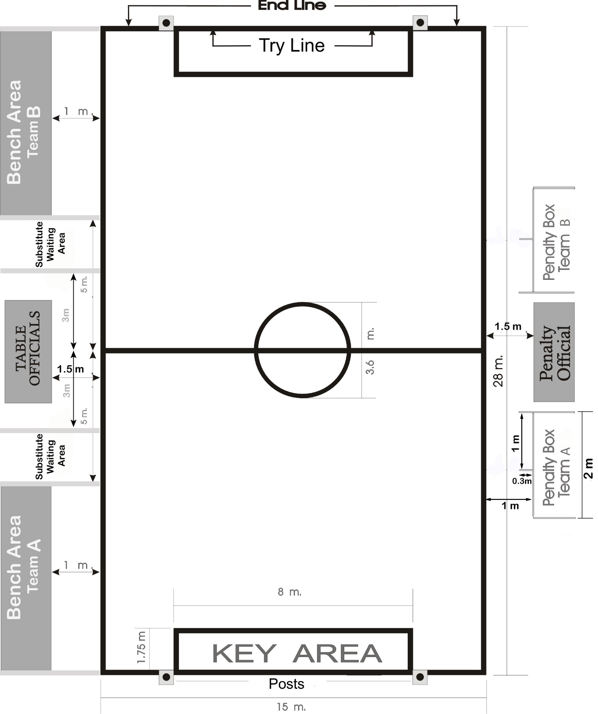
Annex A - Field of play

Annex B – Score sheet
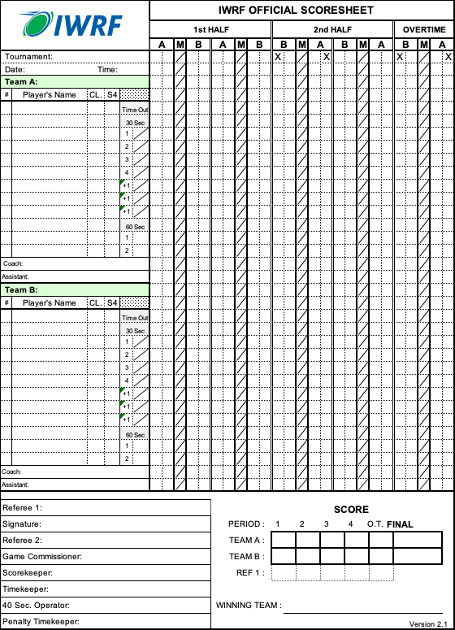

Annex C – Penalty sheet

